Part1 Project

First of all we generate exponensial distribution with lampda=0.2 using 1000 interation and plot its histogram.

lampda=0.2  
hist(rexp(1000,lampda),breaks=15)

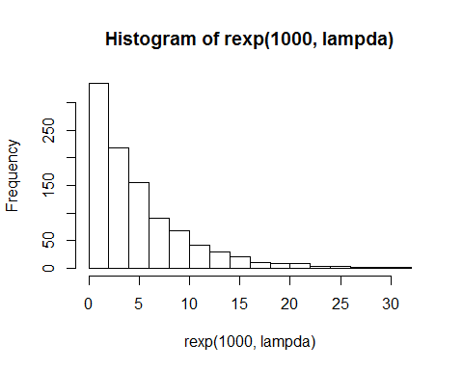

Next step is generating distribution of the mean of exponensial distribution and compare it to the theoretical mean of the distribution. Green line is theoretical mean and red line is sample mean. As we could see they are very close to each other.

mean<-1/lampda  
mns = NULL  
for (i in 1 : 1000) mns = c(mns, mean(rexp(40,0.2)))

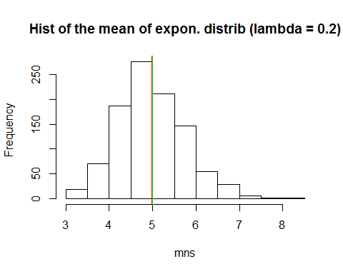

The difference between sample mean and theoretical mean is only 0.0237635.

Then we calculate sample and theoretical variance.

var<-(1/lampda)^2/40  
var_sample<-var(mns)  
dif_var<-abs(var-var_sample)

The difference between sample variance and theoretical variance is also small and comprise 0.0422526

The last step is to compare the distribution with normal. We made a plot with normal density. As we can see histogram of our gererated mean is quite close to normal density with mean=theoretical mean, variance=1/lampda/sqrt(n).

## Warning: package 'ggplot2' was built under R version 3.1.3

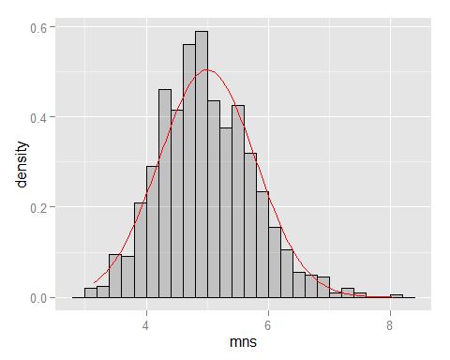

Morover, if we construct confidence interval for the sample mean:

ll <- mean(mns) - qnorm(.975) * sqrt(var)   
ul <- mean(mns) + qnorm(.975) * sqrt(var)

It is from 3.4267489 to 6.5257241 and contains our sample mean of 4.9762365.